Web Application Firewall
objective: The objective of a Web Application Firewall (WAF) is to protect web applications and APIs from common web-based attacks such as SQL Injection (SQLi), Cross-Site Scripting (XSS), malicious bots, and application-layer DDoS attacks by inspecting and filtering HTTP/HTTPS traffic.
prerequisites:
aws
load balancer
ip sets
waf
step by step process:
first we need to create one vpc and 2 subnets and attch to route tables with internet gateway
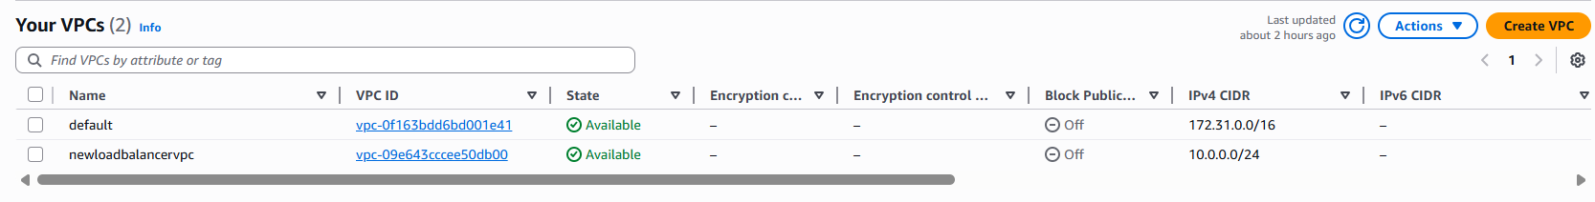
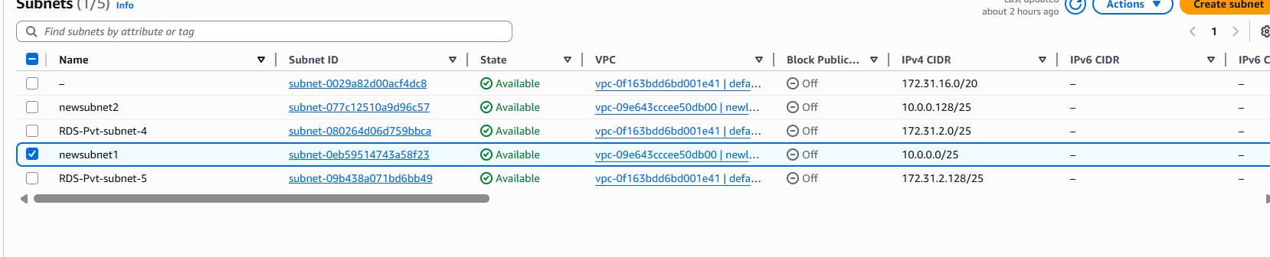
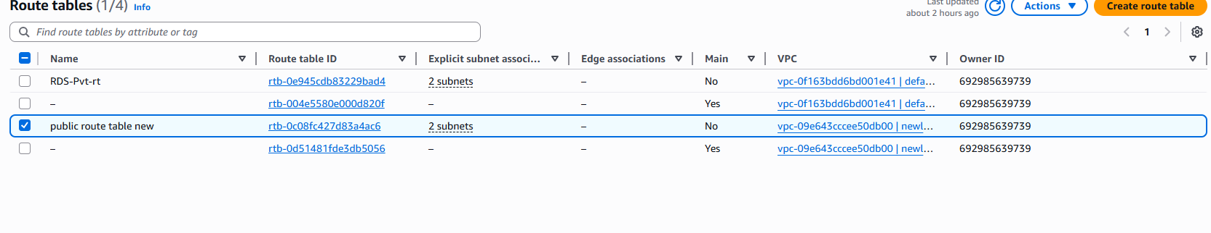
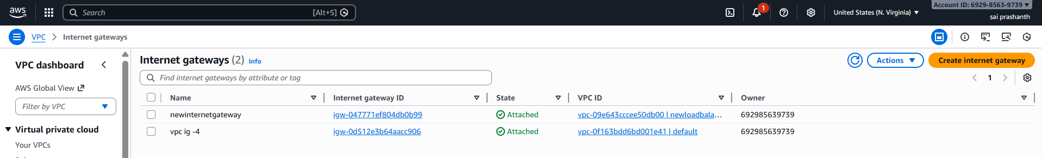
next create 2 instances with two availability zones with two subnets
then connect through ssh in gitbash and install one web server httpd and create one index file with some data or content and try to connect
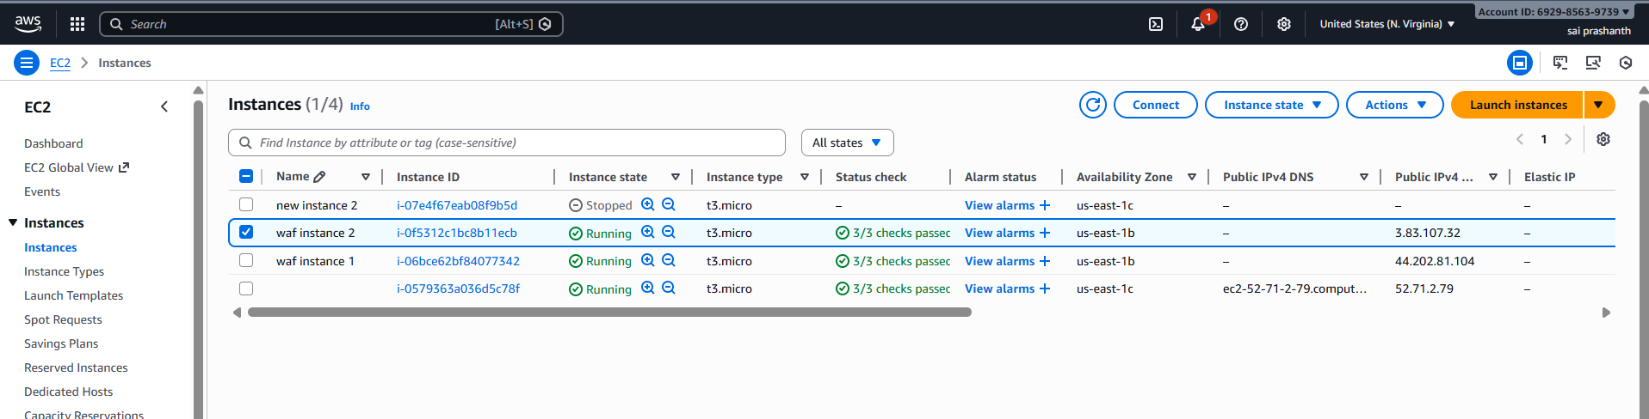
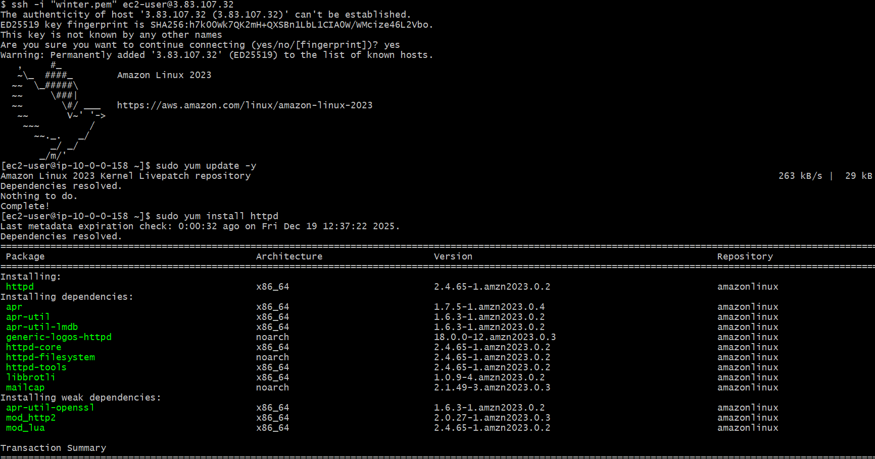
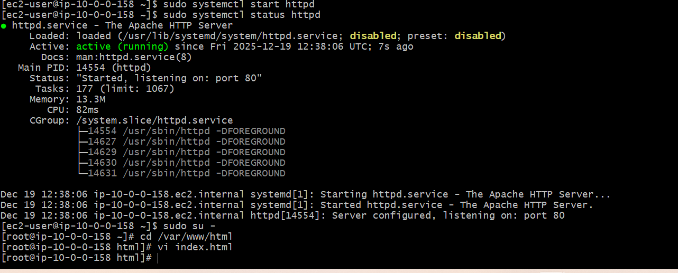
check with public port number with port number 80 for two instances
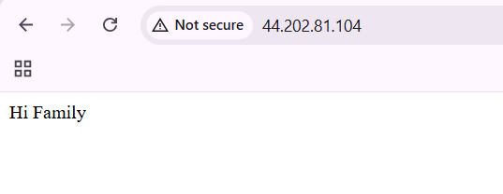
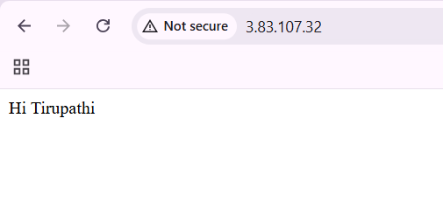
now we need to create load balancer
before creating create target group and attach two instances
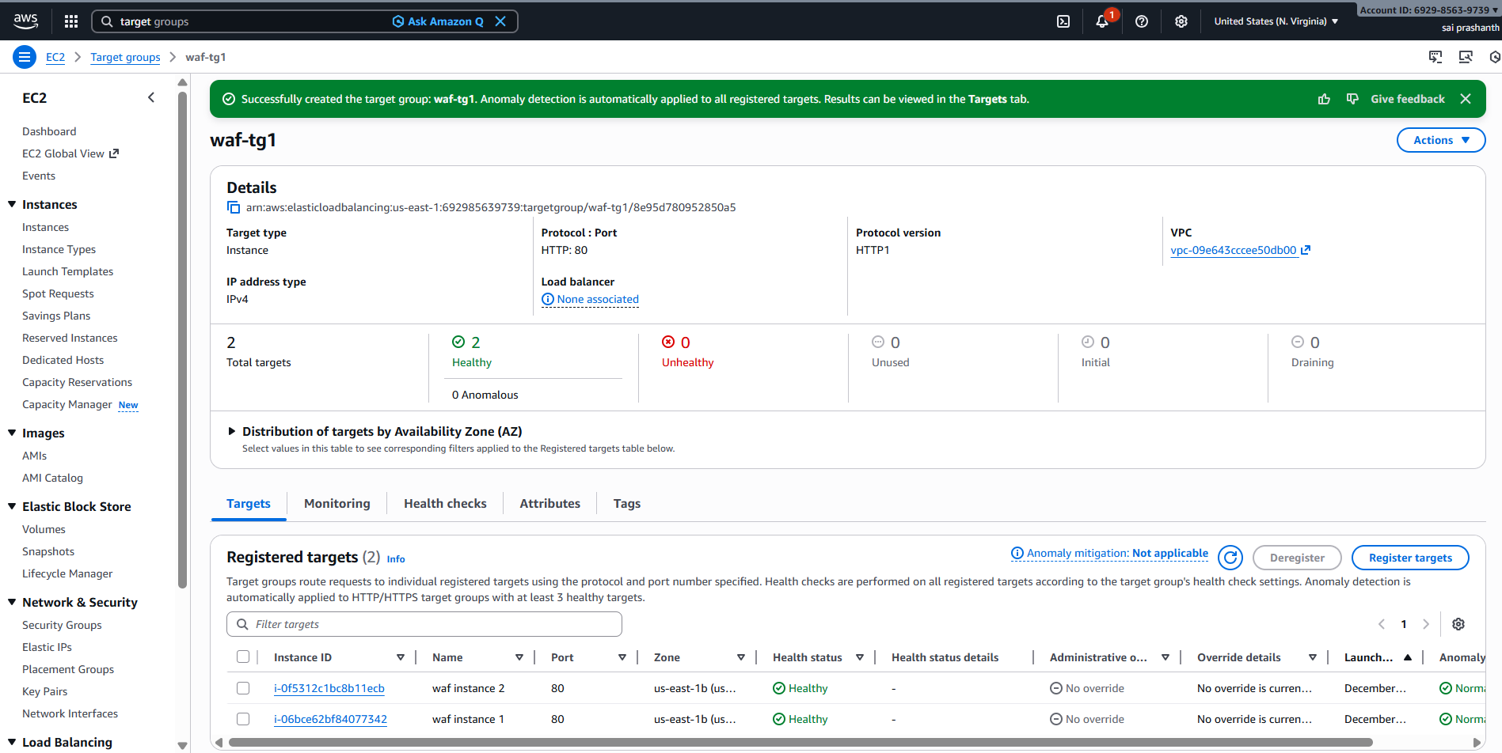
go to load balancer—select application load balancer—click on create—enter the details like vpc, subnets, name and select target group
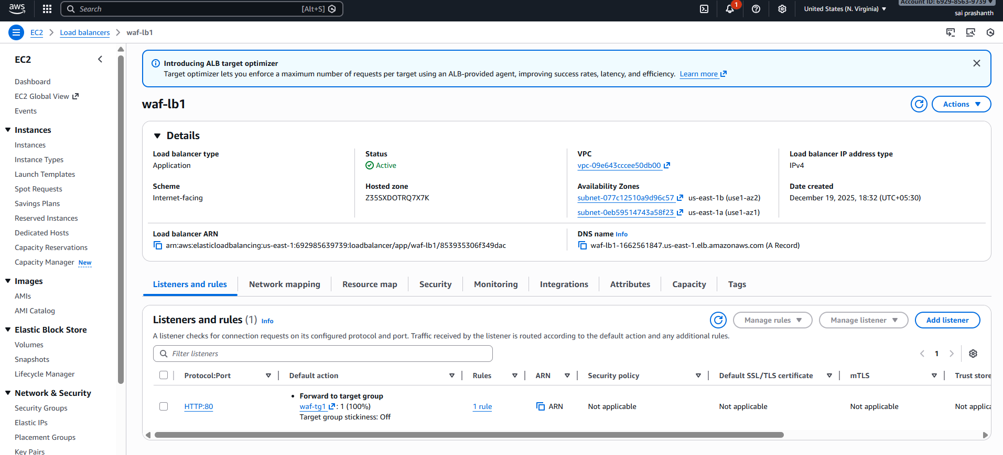
check on browser with lb dns---it’s getting
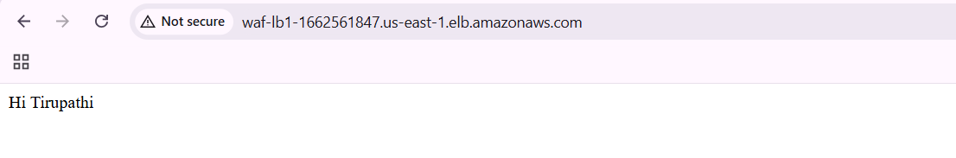
now we need to create one web application firewall and attach it tp load balancer which you have created
go to waf and shield---click on create protection pack
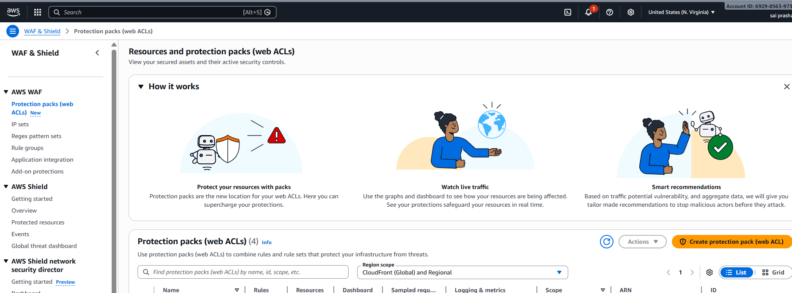

select the category other---app focus both api and web—select the resource your load balancer
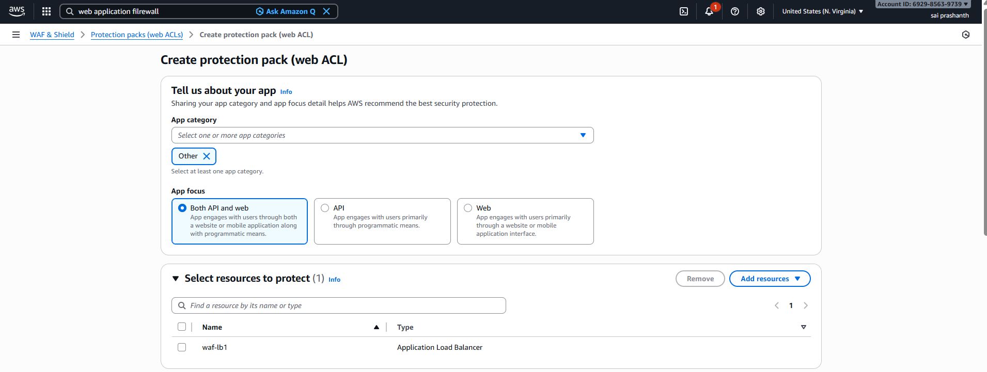
now choose your own pack to create the rule---once you clicked on that—you can see custom rule on the right side—select it for creating your own rule
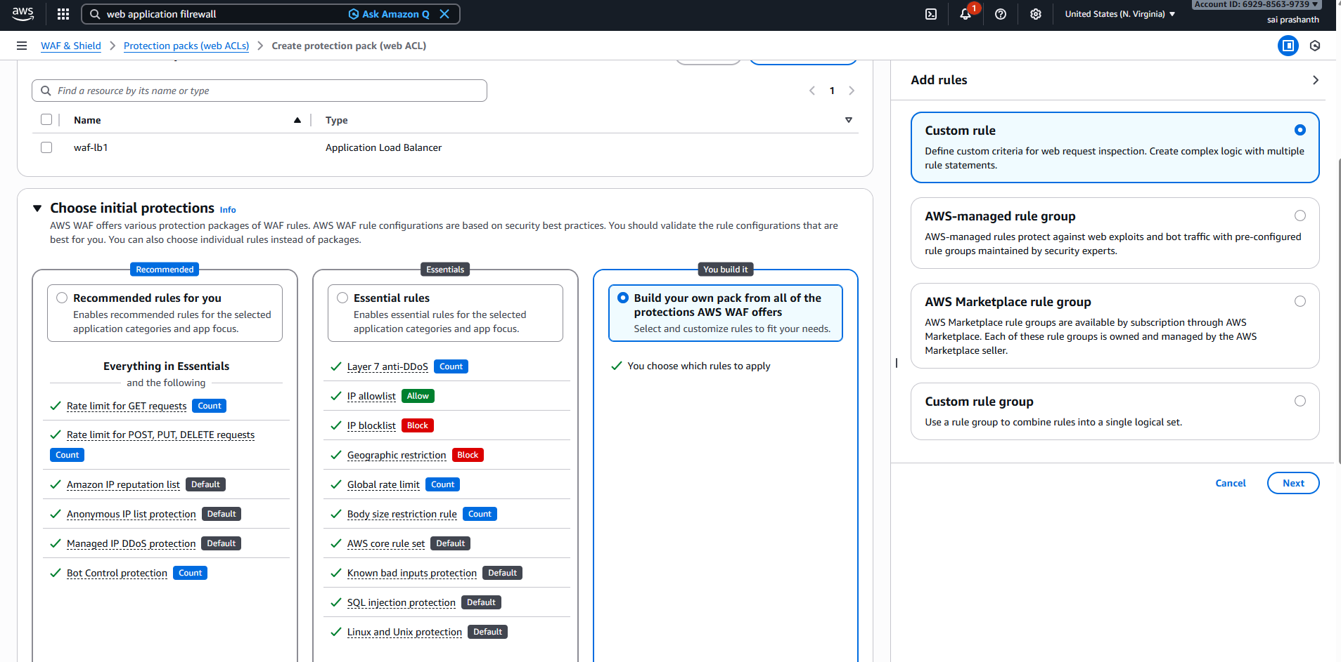

before creating custom rule---click on ip sets

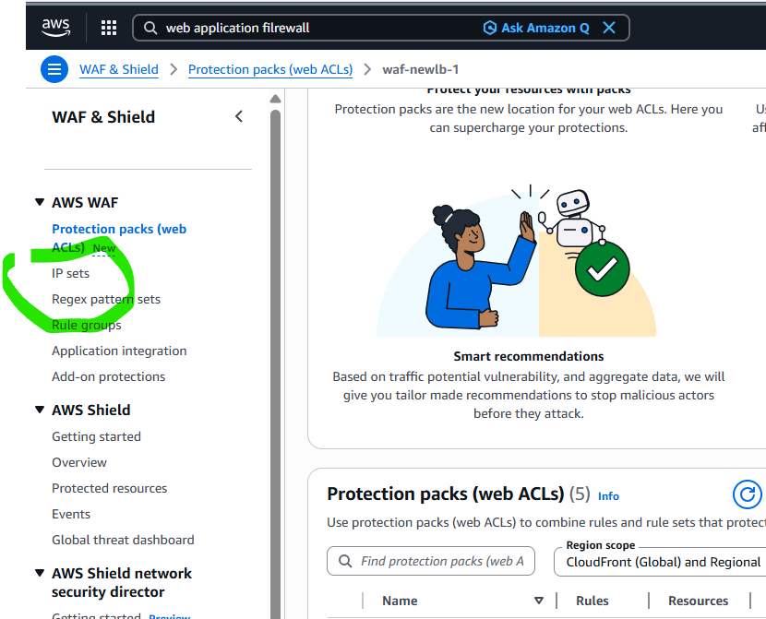
enter your system ip with /32 as it is maximum subnet masking and click on save
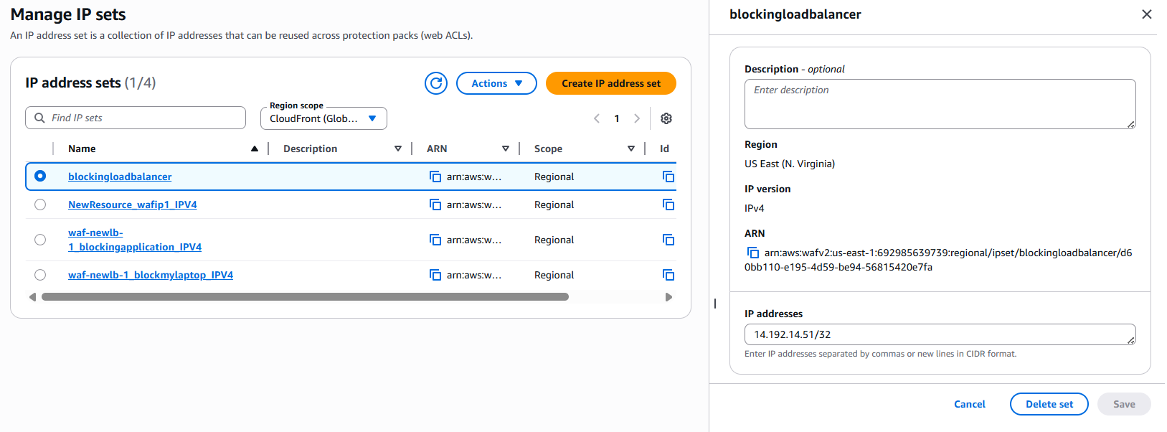

once it has been done you need to attach the rule to firewall
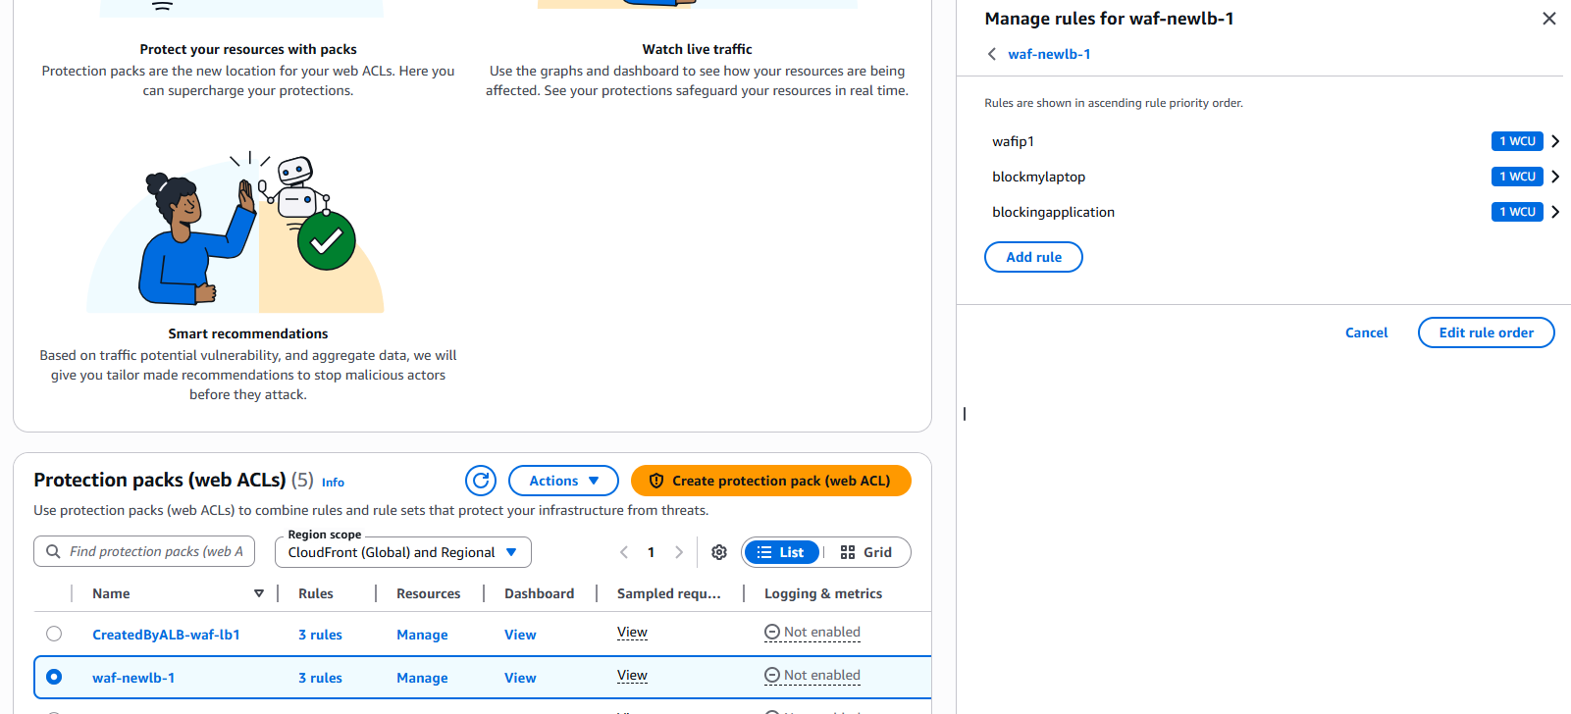validation steps:
once it has been done check with your load balancer link now
it is getting 403 forbidden as it is blocked with my ip
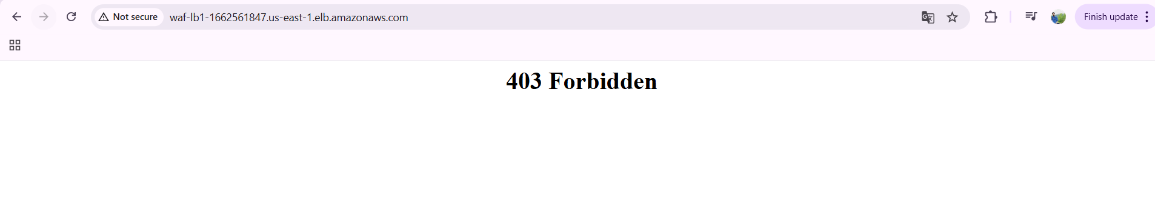
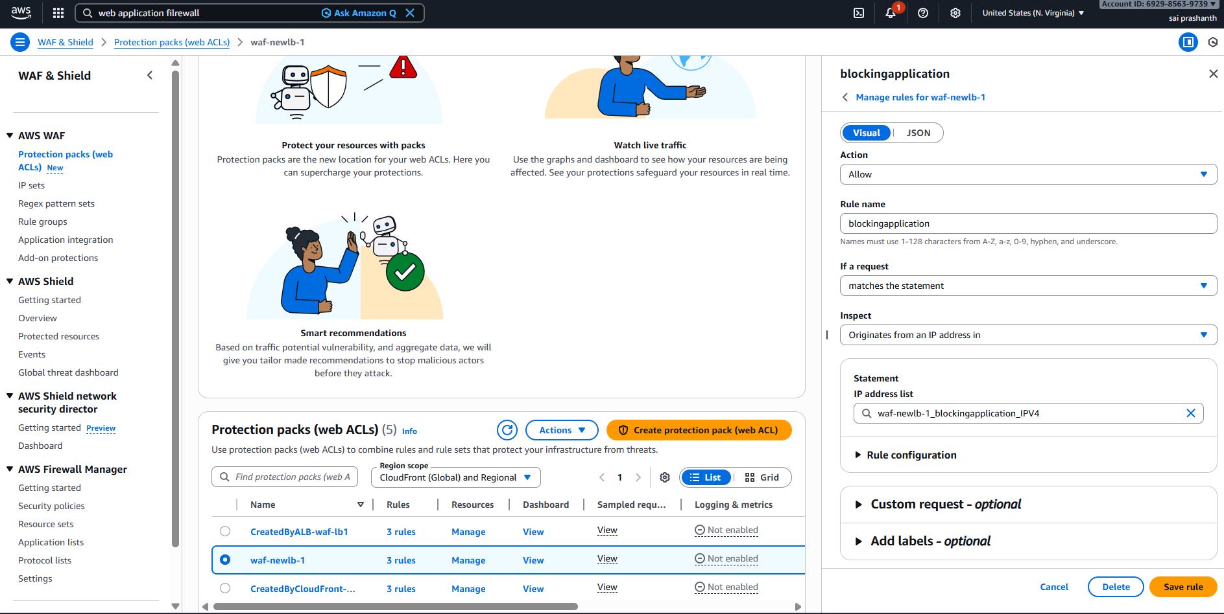
now give allow to your ip
and check now
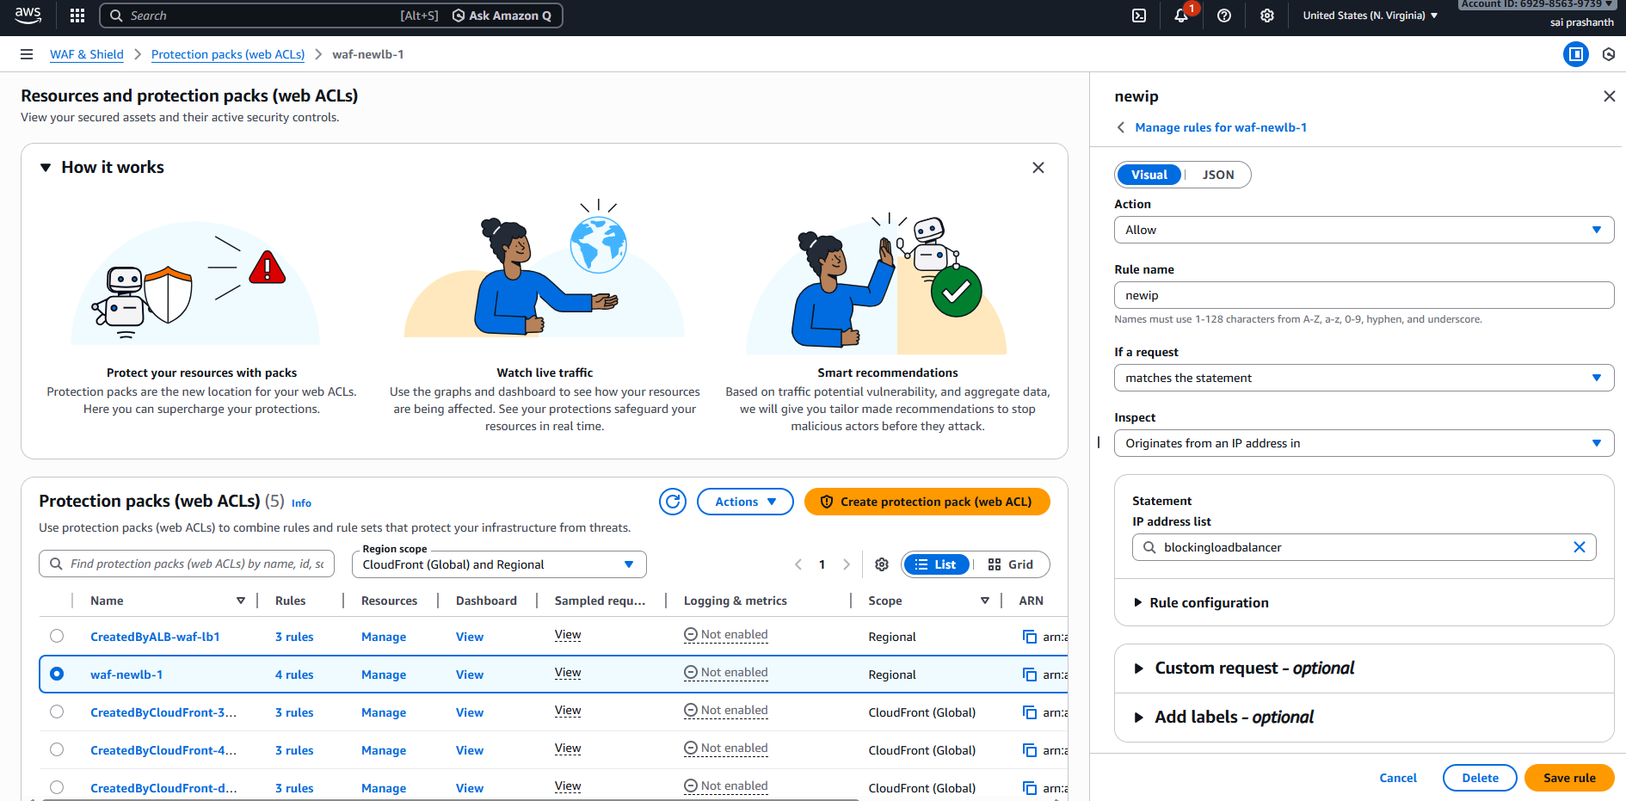
now refresh again with your lb link you can see the access of your data
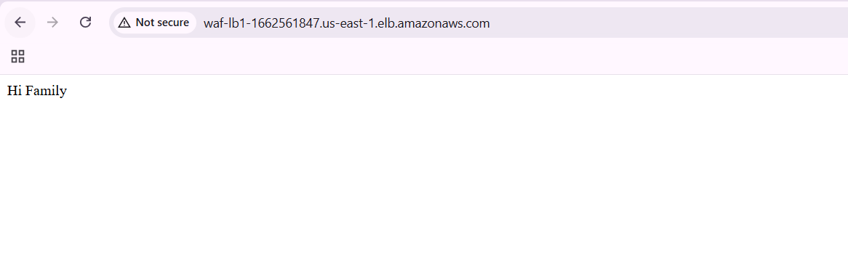
conclusion:
By implementing AWS WAF, organizations can improve application security, reduce attack impact, ensure availability, and meet security best practices in cloud environments.

click on ip-based rules
